Smart Contract Test Coverage Report
Auction Smart Contract Testing and Coverage Analysis

Objective
The objective of this testing process was to validate the correctness, reliability, and security of the Auction smart contract using Foundry-based unit tests and coverage analysis.
The testing focused on:
- Auction lifecycle validation
- Bid placement logic
- Withdrawal mechanisms
- Seller verification system
- Fee management
- Security protections such as reentrancy prevention
- Administrative controls

Testing Framework Used
Tool | Purpose
Foundry | Smart contract development and testing framework
Forge | Test execution and coverage analysis
Solidity | Smart contract programming language

Commands Used
Run Unit Tests
forge test
Generate Coverage Report
forge coverage --ir-minimum
Generate LCOV Report
forge coverage --report lcov --ir-minimum

Test Cases Executed
The following test suites were executed successfully.
Auction Contract Tests
Test Case | Purpose
test_AdminAndSellerManagement | Tests seller registration, verification, and revocation
test_AuctionValidationPaths | Tests auction creation validation logic
test_BidBelowHighestReverts | Ensures low bids revert correctly
test_BiddingAndWithdrawFlows | Tests bidding and withdrawal mechanisms
test_EndAuctionRevertsBeforeDeadline | Verifies auction end restrictions
test_ExtensionAndAuctionEndFlows | Tests seller extension and auction finalization
test_FeesAndViews | Tests fee updates, withdrawals, and view functions
test_LosingBiddersWithdrawExactAmount | Ensures exact withdrawal amounts for losing bidders
test_NoBidsAfterEndAuctionAndSellerReceivesFunds | Verifies seller payout after auction completion
test_Security_ReentrancyGuardPreventsDrain | Tests reentrancy protection
Additional Reentrancy Tests
Test Case | Purpose
test_ReentrancyBlocked | Verifies reentrancy attacks are blocked

Coverage Results
Auction.sol Coverage
Metric | Coverage
Line Coverage | 92.24%
Statement Coverage | 84.83%
Function Coverage | 100%
Branch Coverage | 62.16%

Overall Project Coverage
Metric | Coverage
Total Line Coverage | 87.41%
Total Statement Coverage | 82.72%
Total Function Coverage | 89.29%
Total Branch Coverage | 60.98%

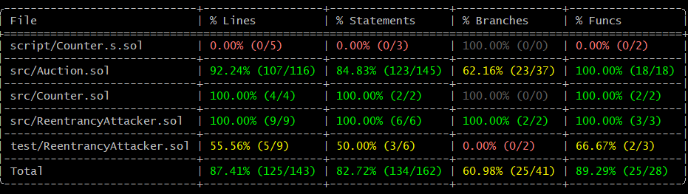

Security Validation
The following security properties were validated:
- Reentrancy protection using OpenZeppelin ReentrancyGuard
- Prevention of unauthorized seller verification
- Prevention of invalid bids
- Prevention of premature auction finalization
- Prevention of double withdrawals
- Proper handling of seller permissions

Observations
- The Auction smart contract achieved more than 90% line coverage.
- All critical auction lifecycle functions were tested successfully.
- Security-sensitive paths such as withdrawals and reentrancy handling were validated.
- No failing test cases were observed during execution.

Conclusion
The Auction smart contract was tested successfully using Foundry.
The contract achieved:
- High line coverage
- Complete function coverage
- Successful validation of security protections
- Stable execution across all implemented test scenarios
The testing results indicate that the smart contract behaves correctly under both normal and adversarial conditions.

